Name: Amogh Nagarkar

Super Set ID: 6403503

**Objectives**

* Explain branching and merging
* Explain about creating a branch request in GitLab
* Explain about creating a merge request in GitLab

In this hands-on lab, you will learn how to:

* Construct a branch, do some changes in the branch, and merge it with master (or trunk)

**Solution:**

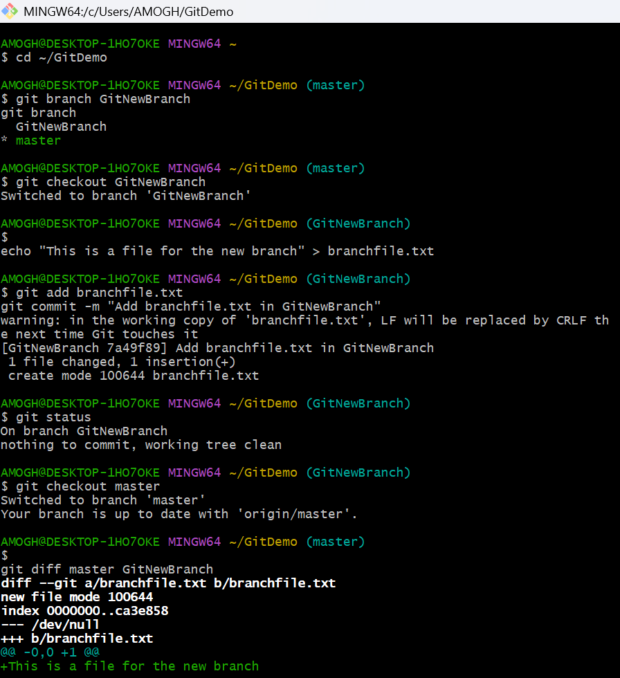

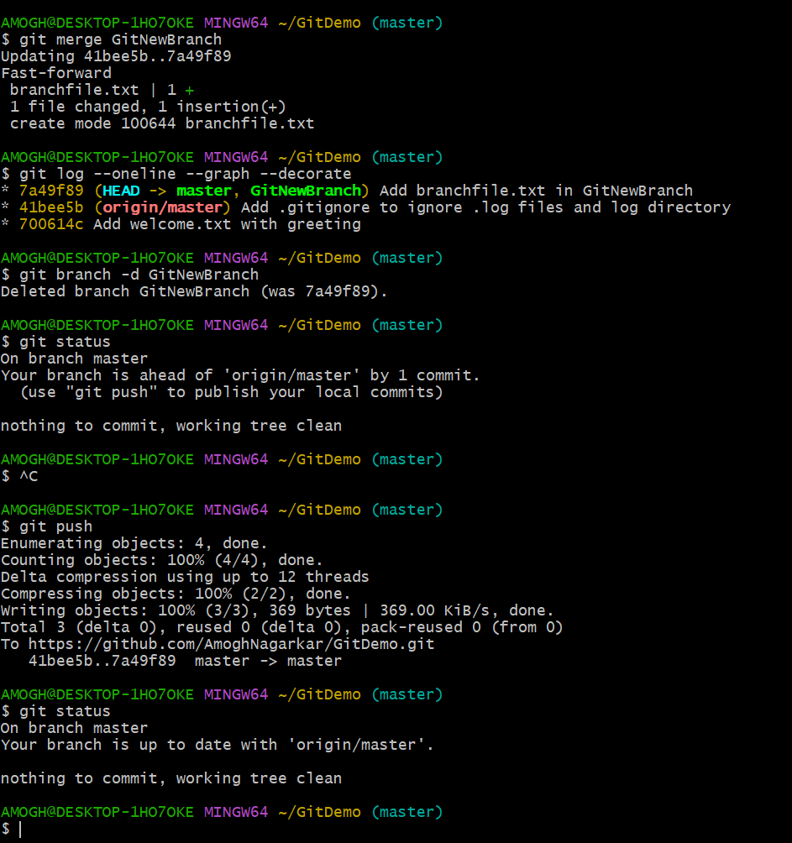

* Created a new branch named GitNewBranch from master.
* Verified branch creation and switched to the new branch.
* Added a new file branchfile.txt with sample content and committed it to GitNewBranch.
* Switched back to master and checked differences between master and GitNewBranch.
* Merged GitNewBranch into master and confirmed merge success by viewing commit history using git log --oneline --graph --decorate.
* Deleted GitNewBranch after merging and verified that the working tree was clean.